 | Abdi İpekçi Caddesi Kaşıkçıoğlu Apt. No:42 D:2 34365 Nişantaşı İstanbul  www.artxist.com  info@artxist.com  T. +90 212 291 77 84 F. +90 212 343 69 35 | PRESS RELEASE

NOT NOW
The fiction and characters created by Cem Dinlenmiş are not limited to his works in Penguen Magazine.
In his upcoming solo show ‘Not Now’ which will open on 29th of March at x-ist, Dinlenmis presents his brand new works, blended with his sense of humour and invites the audience to play.

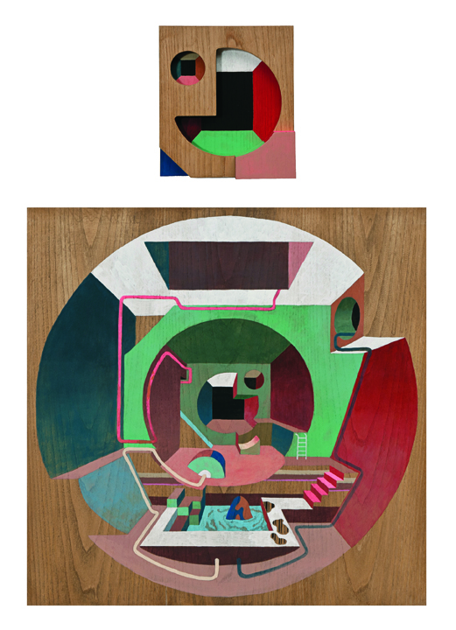

Cem Dinlenmiş, Deus Ex Machina, Marker and acrylic on wood (2 pieces), 90 x 60 cm, 2012

In his new exhibition “Not Now”, Dinlenmiş not only develops his multi-layered and many-faceted works we know from his previous show “Internal Affairs” with new tricks, but also – for the first time - interprets daily, semi-autobiographical scenes with his unique style. He does not produce works aiming for the existing surface; instead, he shapes the given canvas or wooden surface in accordance with his story or idea and enables perceptions that vary with the position of the audience. The two-piece body in the exhibition makes up an abstract portrait by combining the second and the third dimensions whereas the real life scenes are revived with endless details, turning into puzzles. It is inevitable not to get lost in Dinlenmiş’s works.
Maintaining his storytelling in large-sized canvases, Dinlenmis also uses typography properly. In the three-dimensional work “Artistic Territory” his ironic approach is directed to the work itself and art’s status as a commercial tool is discussed.
“Not Now” can be seen until April 21st , 2012 in x-ist.

Cem Dinlenmiş, İstanbul, 1985
After the group show, Intersection III (2008) in x-ist, Dinlenmiş had his first solo show titled Internal Affairs in 2009. The other group exhibitions and fairs he has participated are “Connect the Dots”, (Hafriyat, Karakoy, Istanbul, 2008), “Young Istanbul” (Färgfabriken, Stockholm, 2008), “Destroy Istanbul” (Berlin, Germany,2011), Contemporary Istanbul ’09, 10, 11 and Art Dubai 2011. The artist is graduated from the Marmara University, Fine Arts Faculty, Graphics Department and is a regular contributor to the acclaimed Turkish humor magazine Penguen.

The portraits in ‘Full Contact’ are the pieces where the artist establishes the closest relations with the subjects. Women stand out with their femininity while men display their masculine power. However, with
One major commentary of the artist on today’s contemporary art scene is regarding the use of art as a tool for exchange rather than of sharing. The preset conditions, regulated by people who has control of the information systems, lead to the commercialization of art, force artis

